**Lesson 5 Demo 4**

**Integrate Maven with Jenkins**



Steps to be followed:

1. Installing Maven plugin
2. Setting the Global Tool Configuration
3. Forking a sample repository
4. Integrating Maven with Jenkins

**Step 1: Installing Maven plugin**

* 1. Open the browser, and go to **Jenkins dashboard** by typing **localhost:8080** in your browser.

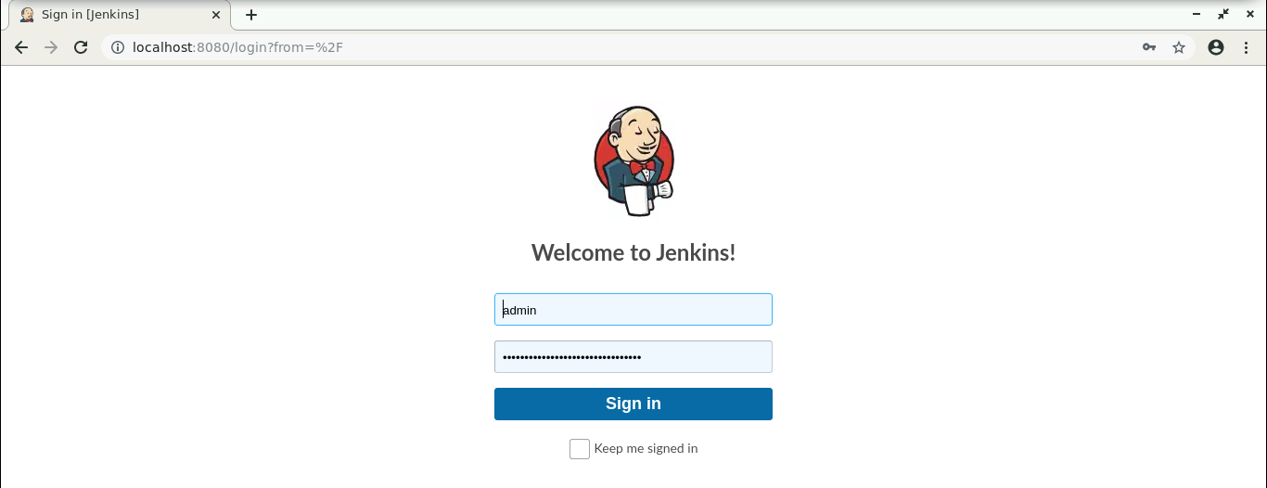

* 1. Provide the credentials, and click on **Sign in**.
  2. Click on **Manage Jenkins**. From the list of options, choose **Manage Plugins**.

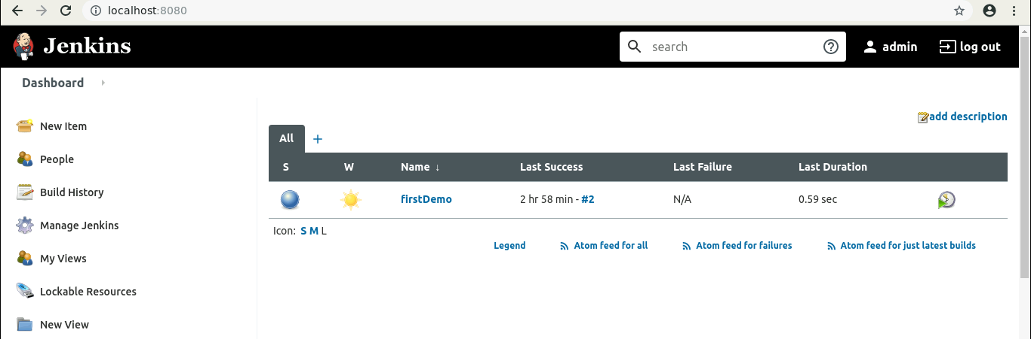

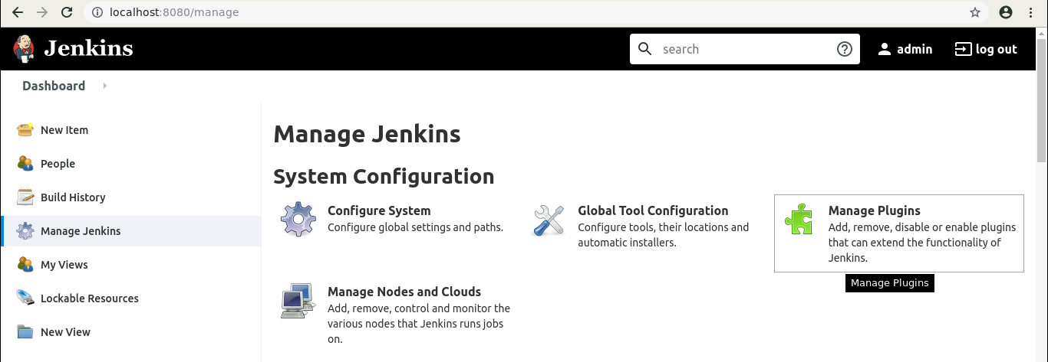

* 1. Under the **Available** tab, search for **Maven** plugin.

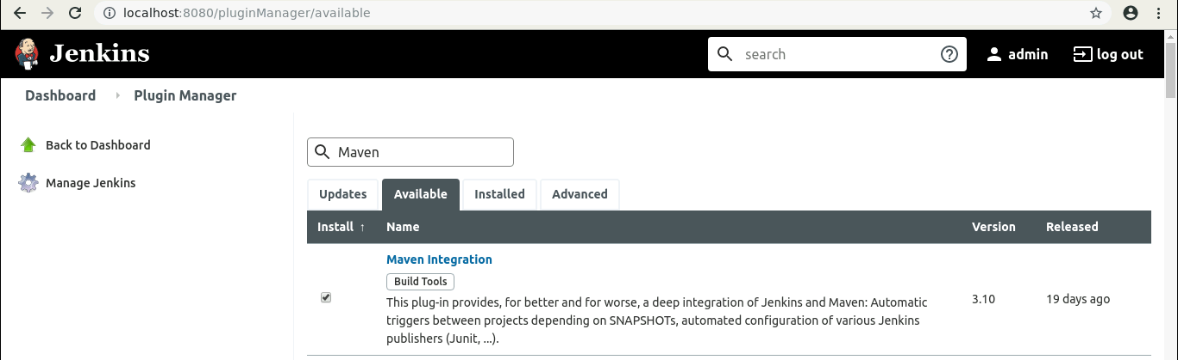

* 1. Select the checkbox in front of the **Maven Integration** plugin,and click on the **Install without restart** button.
  2. The Maven plugin will get installed.

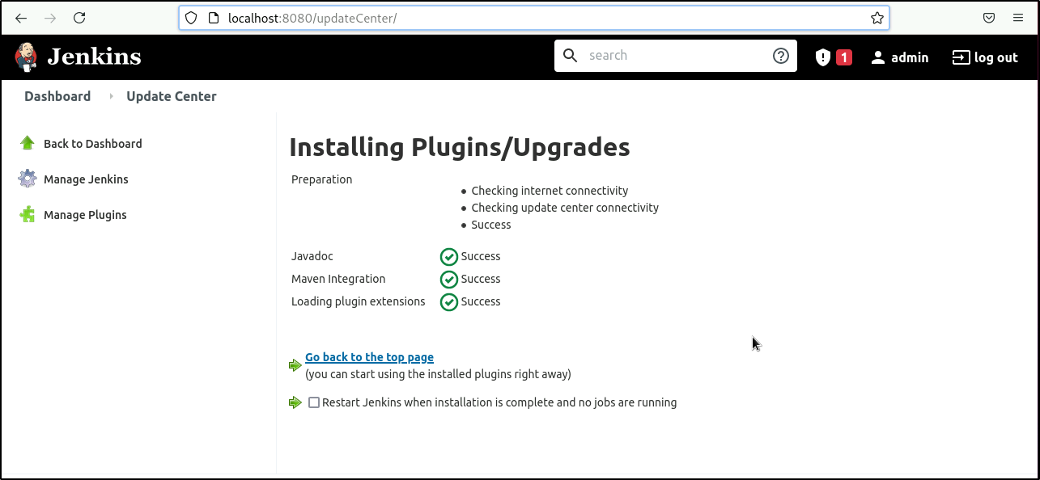



***mvn -version***

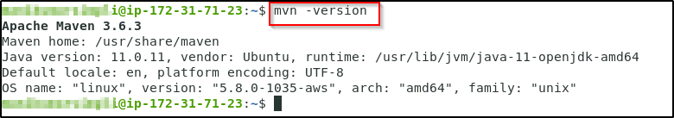

*This information will help you in setting up the Global Tool Configuration.*

**Step 2: Setting the Global Tool Configuration**

* 1. Go to Jenkins **Dashboard**, click on **Manage Jenkins**. From the list of options, choose **Global Tool Configuration**.



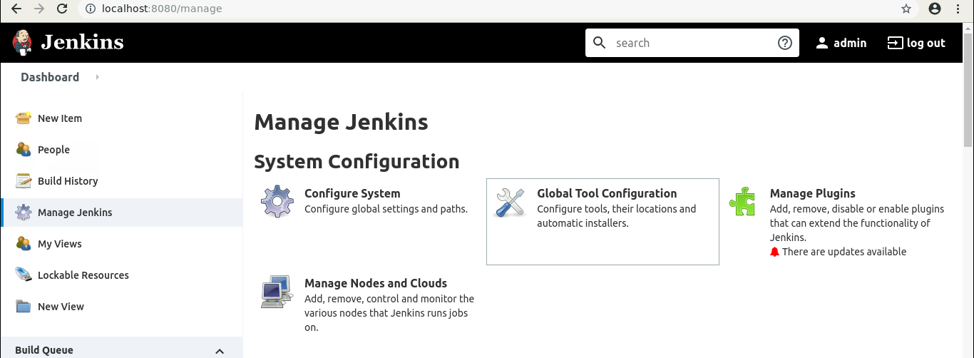

* 1. Click on **Add JDK,** and provide the **Name** and **JAVA_HOME** path. Uncheck the ***Install automatically*** checkbox.

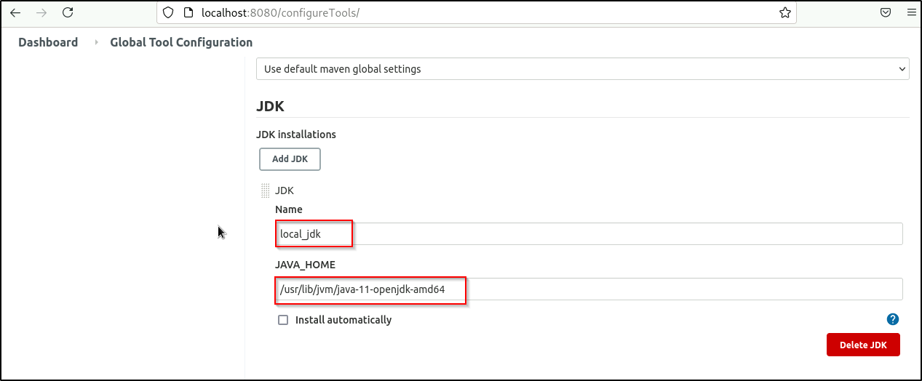

* 1. To configure Maven, click on **Add Maven** button in the Maven section, enter any **Name** and **MAVEN_HOME** path. And uncheck the ***Install automatically*** checkbox.

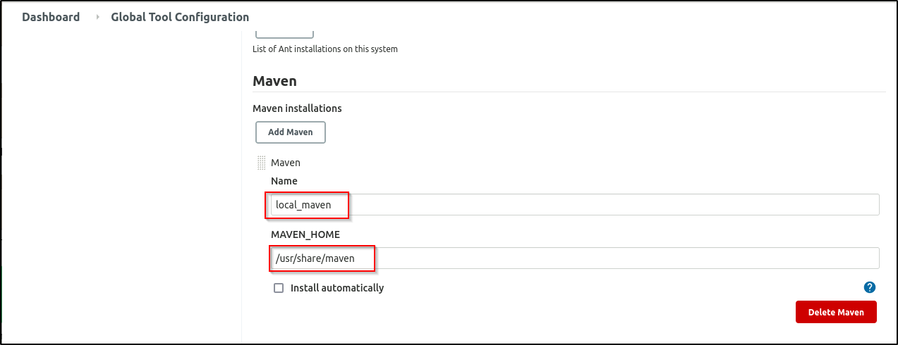

* 1. To configure Git, click on **Add Git**, and enter any **Name** and **Path to Git executable** path.

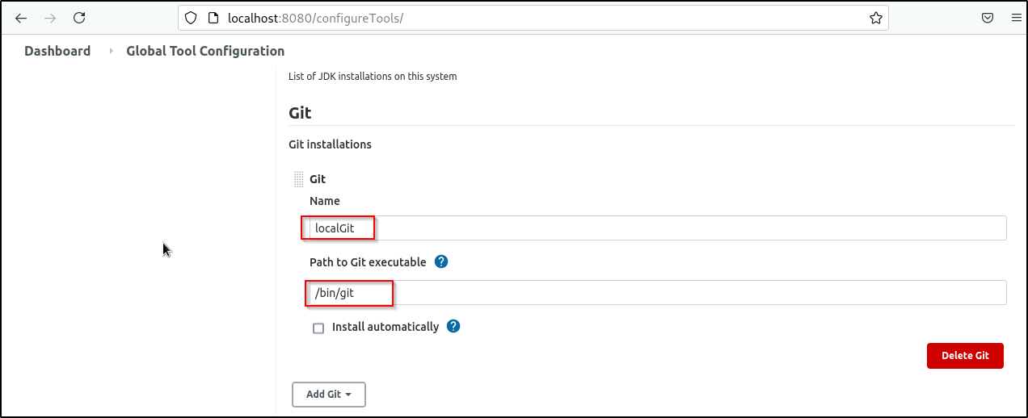

* 1. Click on **Save**.

**Step 3: Forking a sample repository**

* 1. **Login** to your Github account.
  2. Navigate to <https://github.com/jenkins-docs/simple-java-maven-app>, and click on **Fork**.

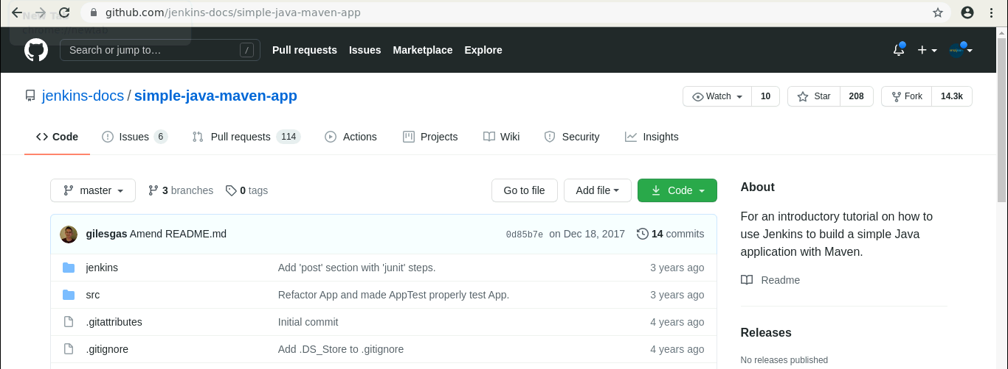

* 1. Open the terminal.
  2. Run ***git clone [Forked_REPO URL]*** to clone the repo locally.

**Step 4: Integrating Maven with Jenkins**

* 1. Click on **New Item** in the Jenkins dashboard.

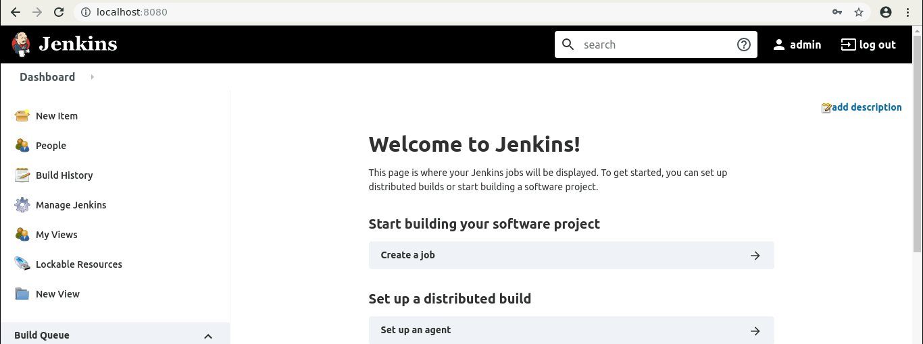

* 1. Enter a name for your project.
  2. Select **Maven project** as the build job type.

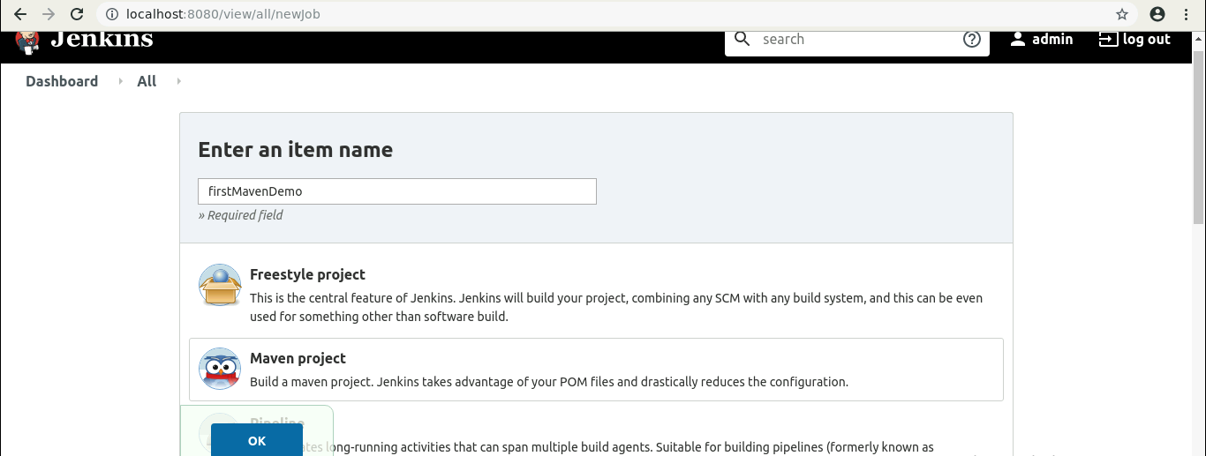

* 1. Click on **OK**.
  2. Scroll down to the **Source Code Management section,** and select Git.
  3. Enter the repository URL.

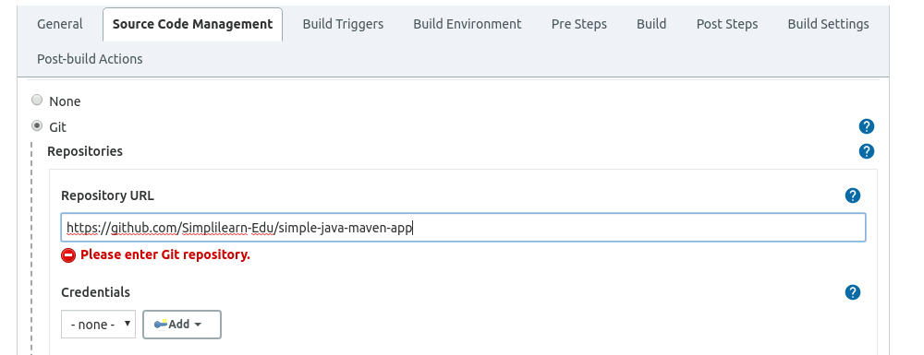

* 1. In the **Build Triggers** section, select the required option.

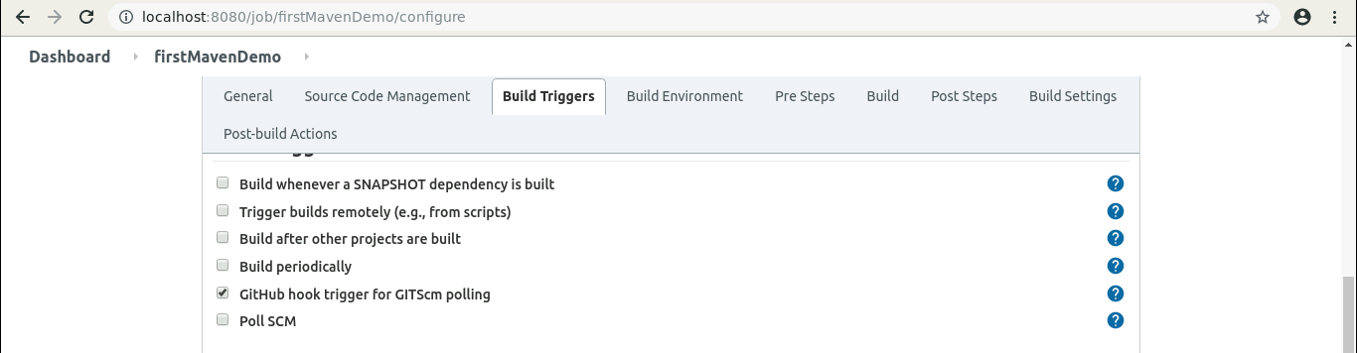

* 1. Click on **Save**.
  2. Click on the **Build History**to view the build results.
  3. Click on the **Console Output** to view the build logs.

